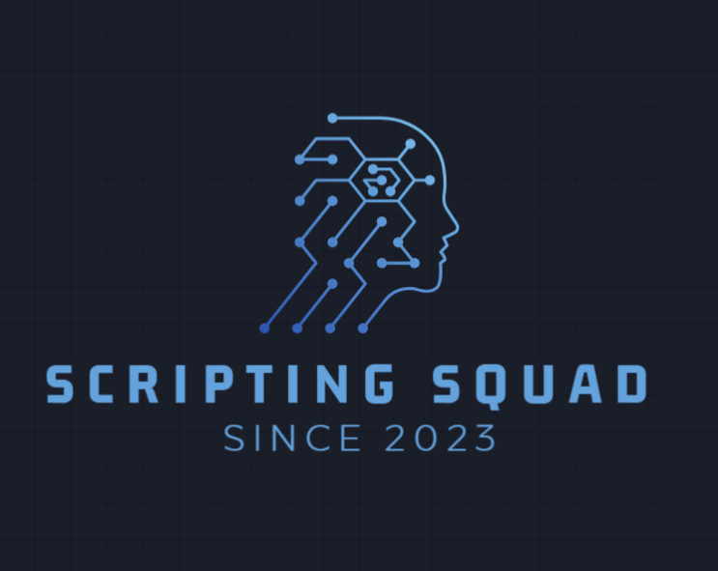

“FINAL PROJECT”

BANO QABIL 2.0 (2023 – 2024)

(CIT with Python)

**INTRODUCTION TO OUR TEAM:**

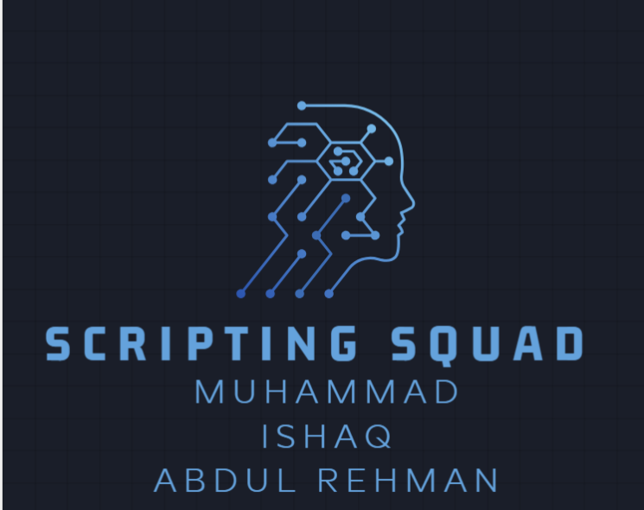

**FINAL PROJECT:**

**“WORD GUESSING GAME”**

DESCRIPTION OF OUR GAME:

We designed our program like we provide which make easy to guest the fruit or flower name easily first letter and the last letter of fruit or flower e.g. (a_ _ _ e)=>(apple) or (r_ _e)=>(rose).Where user is allowed to guess the words by alphabets by no of attempts.

* HOW IT WORKS?

When user enter in game they faces a welcome interface , after that they will reach to the game interface by clicking on play button. Step by step user enters their guesses according to their knowledge if they then they will be congratulated if they fail they will be provided with game over interface.

* EXPLANATION OF CODE AND LOGIC DESIGNS:

It is designed according to given instructions and in order to make word guessing game this code is provided with while loops and if conditions and further it is also provided with proper indentation to get proper output and proper comments are also included in this code to define what is going on in this coding.

**PICTURES WHICH ARE USE IN INTERFACE:**



**INPUT:**

Now I will show you the input code through screen shot.

LIBRARIES/DEPENDENCIES:

#import pygame.

Go to the terminal of “ VISUAL STUDIO CODE” and write “pip install pygame”. Now if you run the python code you will be able to run the game.

INPUT CODE:

Now I will add some screen shot of the input code.

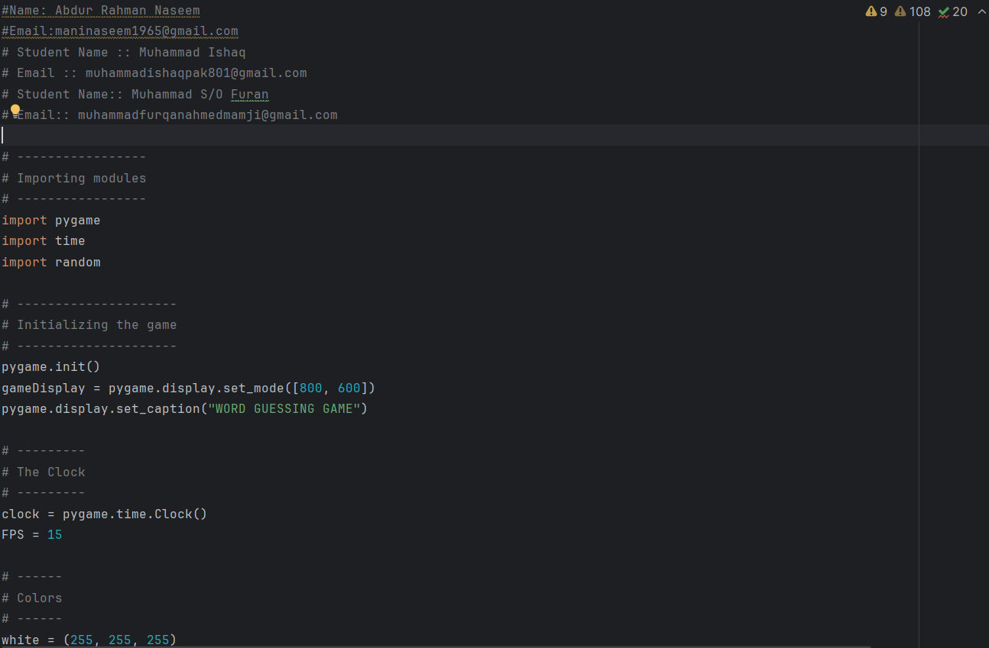

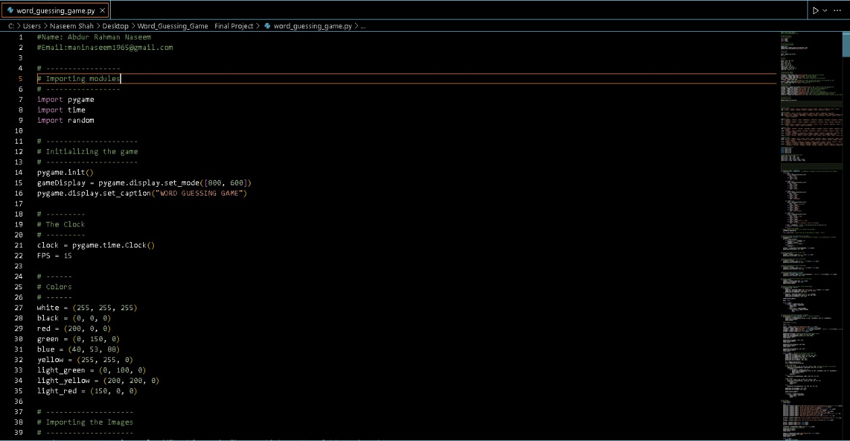

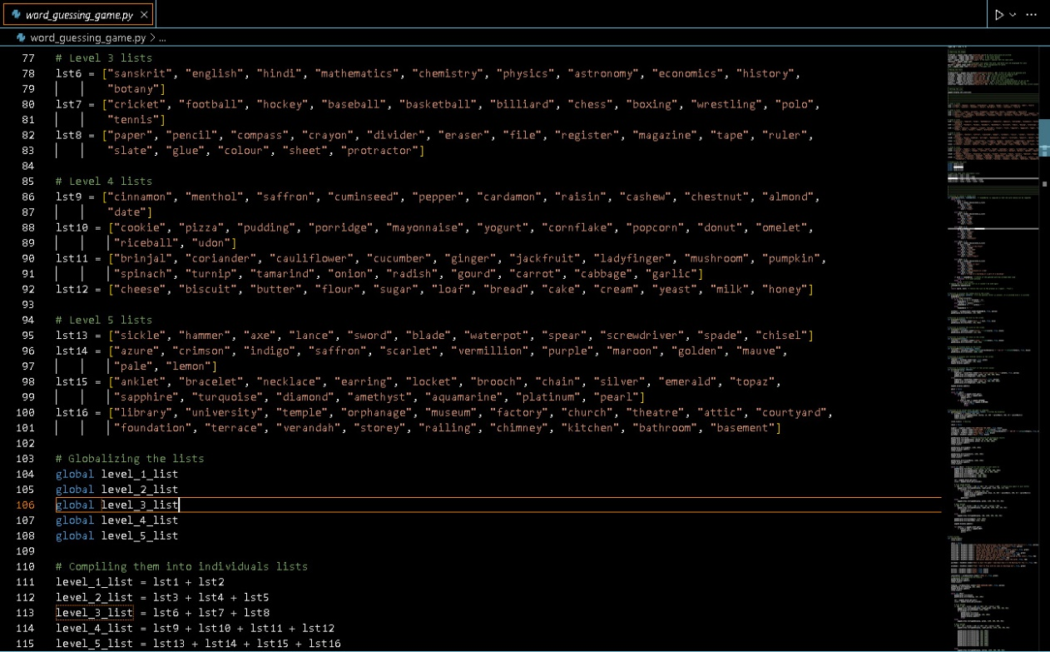

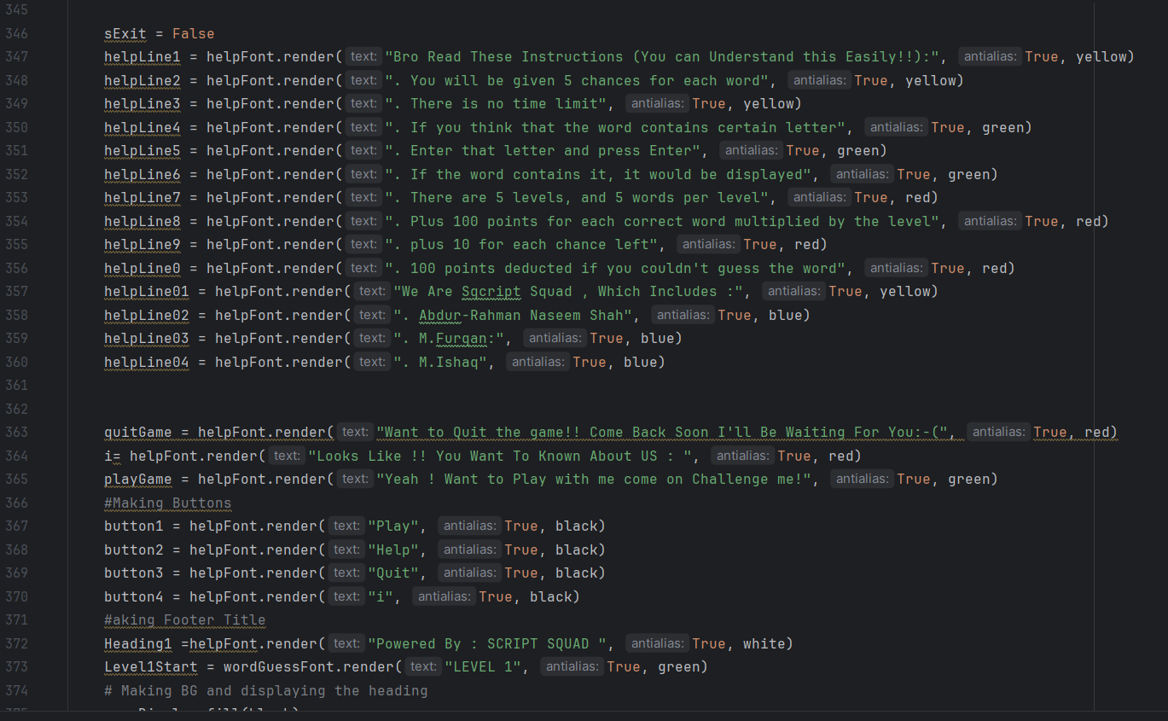

**OUTPUT OF THE PROGRAM:**

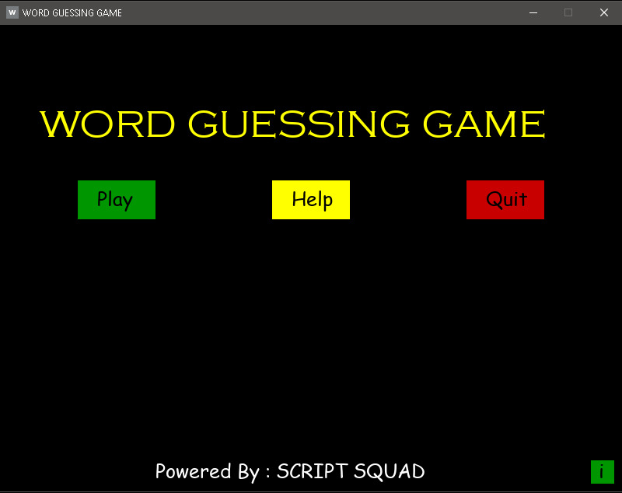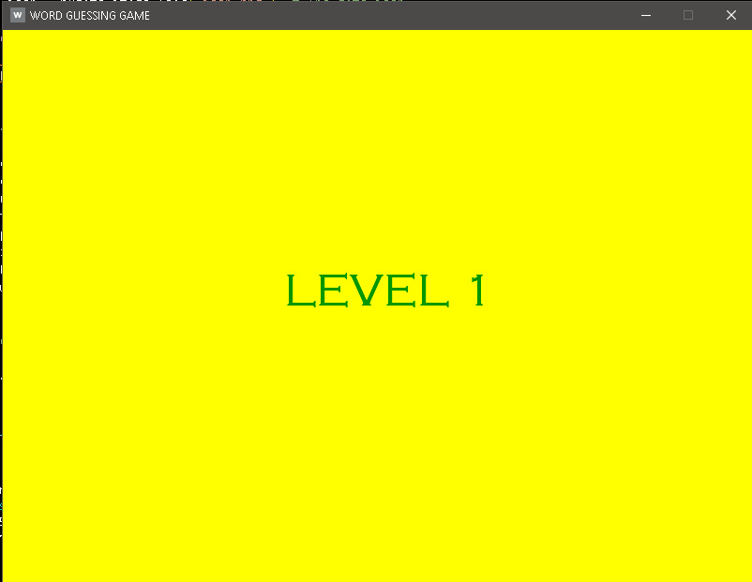

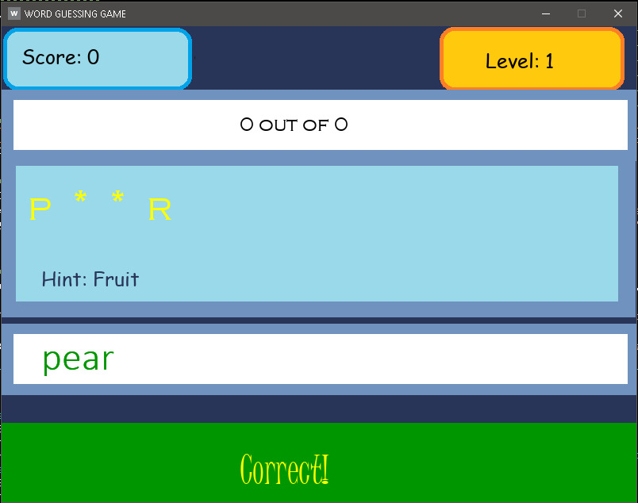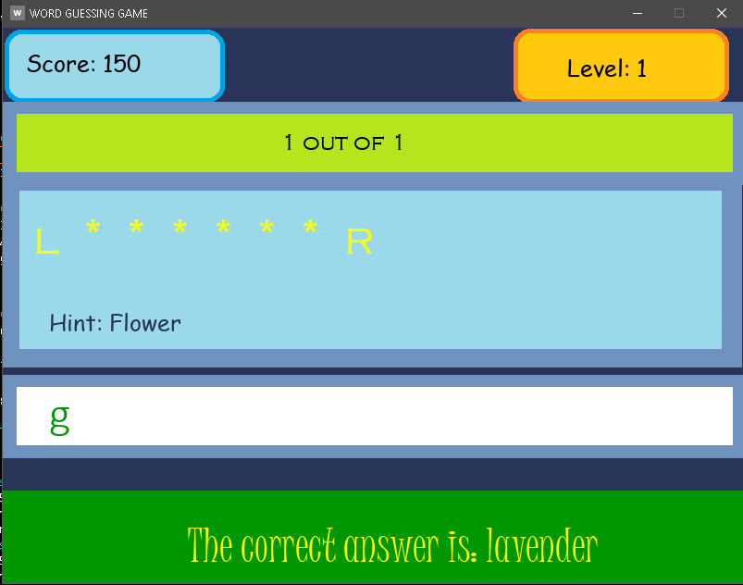

Github Repository Link:

<https://github.com/naseem1965/Bano-Qabil_python_Course/tree/main/Final_Project/Word_Guessing_Game%20%20%20Final%20Project>

THAT’S ALL FROM US